REMEMBER TO NOT SHARE OR LEAK THE DESIGN TO THE GIRLS!!! **PLEASE PLEASE PLEASE BE CAREFUL WHEN YOU MAKE THE BRACELET AND DO IT RIGHT THE FIRST TIME! WE DO NOT HAVE SPARE MATERIALS!!!**

**Materials given:**

* 6 ft (152 cm) Scarlet Red Paracord = Moss Green Paracord
* 6 ft black paracord (For Seniors/Coaches) = Gold Paracord
* 6 ft white paracord (Non-seniors) = Gold Paracord
* 4 ft black paracord (bracelet core/base)
* 9 ft burgundy paracord = Tan Paracord
* 6 ft Gold microcord

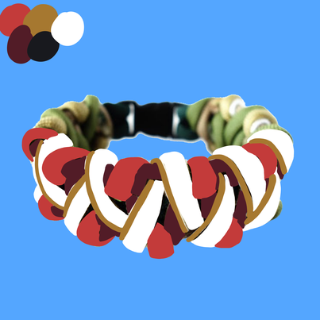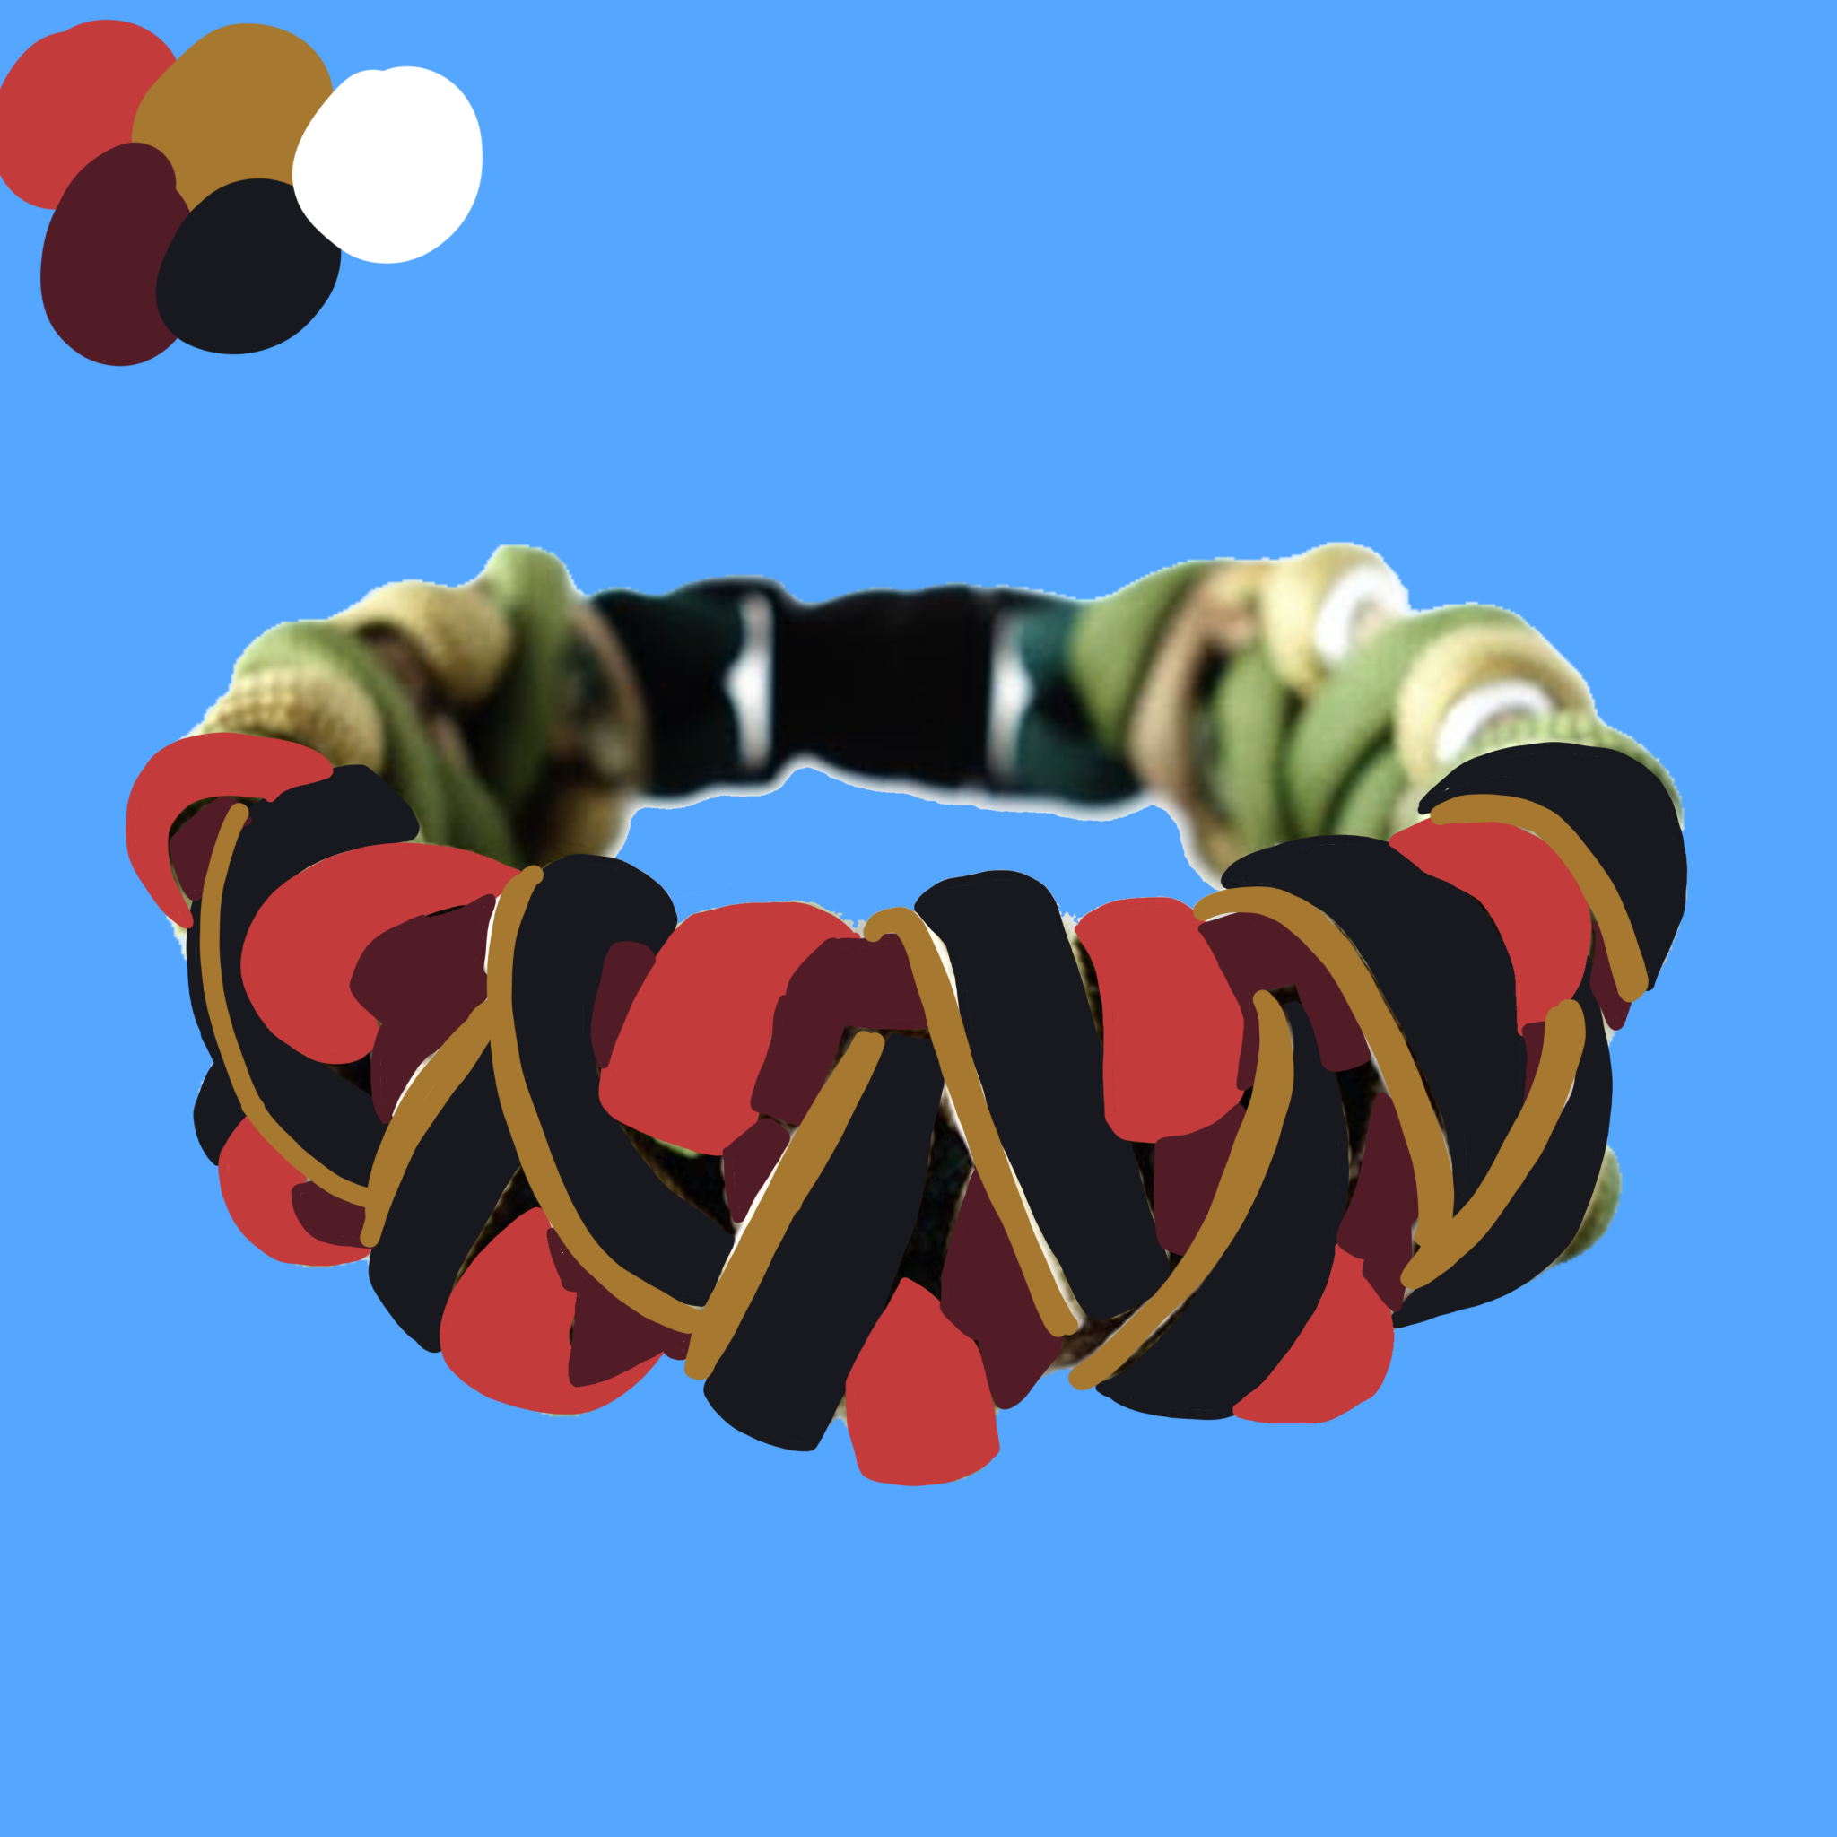

**Videos:**

[**HOW TO MAKE BRACEL2ET CORE - STOP BEFORE HE STARTS MAKING THE WHOLE BRACELET**](https://www.youtube.com/watch?v=o_KeUSrmRKY&t=316s)

[**How to Make the Solomon's Fire Groot Themed Paracord Bracelet Tutorial**](https://www.youtube.com/watch?v=U2WD6CIoQb8&t=1s)